Creating an EPICS server via a LabVIEW project
- Create, and save, a project and add the appropriate VIs to it
- Right Click on “My Computer” in the project then drill down as follows: New > I/O Server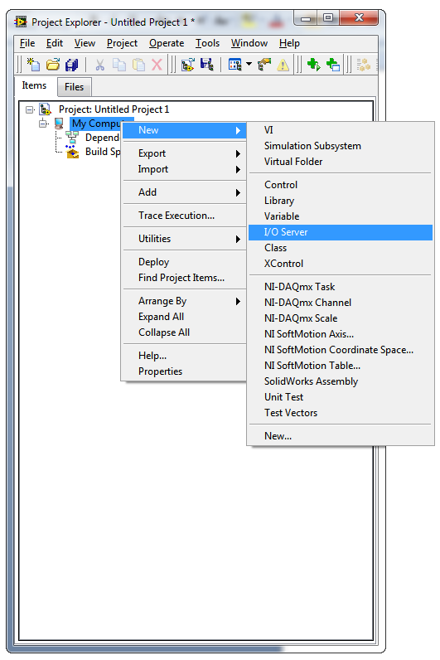
- Select EPICS Server 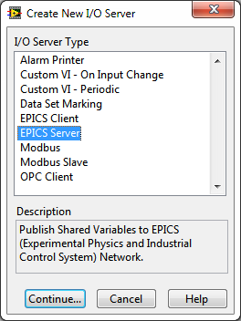, and click on Continue.
- Click on OK.
- Saving the project now will prompt you to save the lvlib that LabVIEW created that contains the server. Make this library name simple and easy to remember and unique to the subnet the code will be run on, as this will form part of the process variable name, so short and meaningful is vital.
- Rename the EPICS Server from the generic name into something more meaningful.
- Create the first variable in a logical location, right click then drill down through New to Variable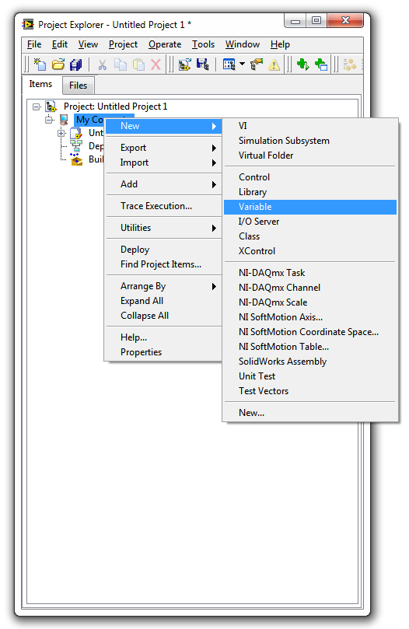
- Ensure that the Variable Type is set to Network Variable (the default) and that the Data Type is correct, click on OK.
- Another new library will have been corrected, along with the variable, if you didn’t name the variable in step 8 you can do so now, making sure to keep the name meaningful as this again part of the process variable name.
- Saving the project now will prompt you to save the lvlib that LabVIEW created that contains the variable. The name of this lvlib isn’t too much of a problem so name it in the most appropriate manner.
- Create extra variables within the latest lvlib as required (1 per front panel item to be accessed)
- Right click on the EPICS server and elect to create bound variables 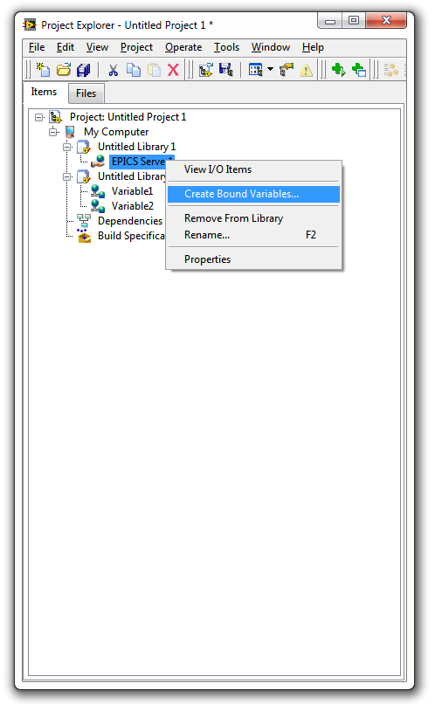
- In the next screen drill down through the project to the created variables and Add them to the bound variables list for the server and click on OK. 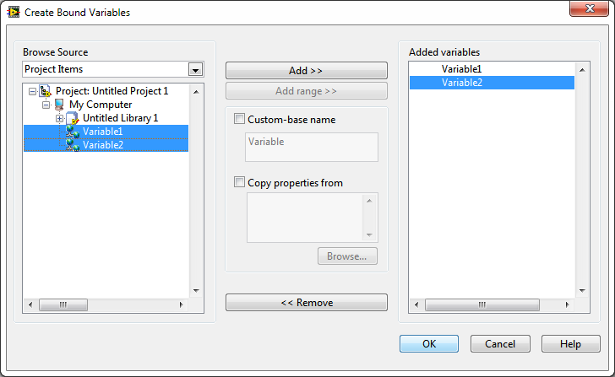
- Click Done in the next screen.
- Go into the Properties of the Server (Right Click on the server, select properties) 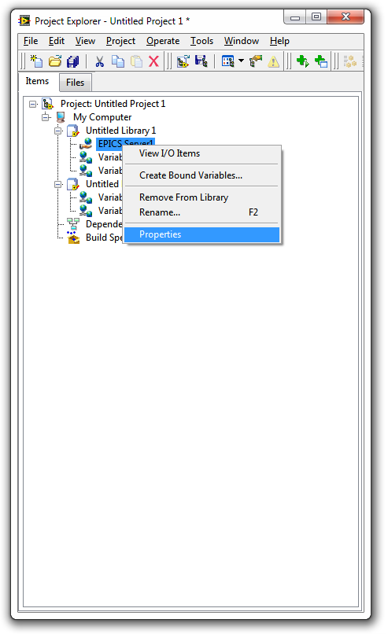
- In the next screen select Add/Remove Variables 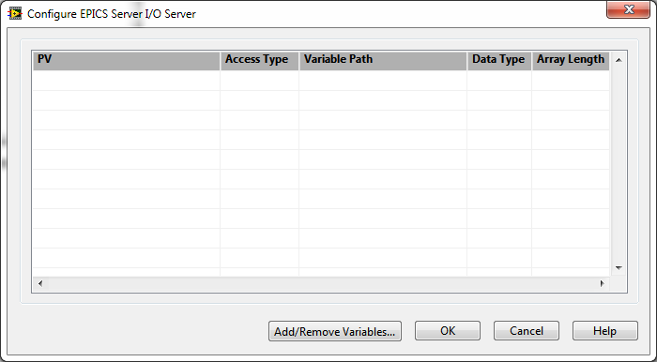
- Drill down to the Variables in the same library as the server and Add them to the Added Variables list. 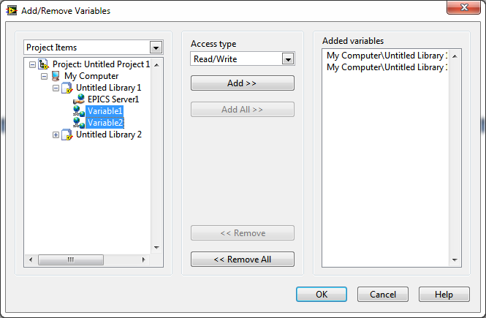
- Note that this will now give you a screen with the PVs for that server listed as seen here, and that the names are made up of host_machine:EPICS_Server_Lvlib_name:Variable_Name 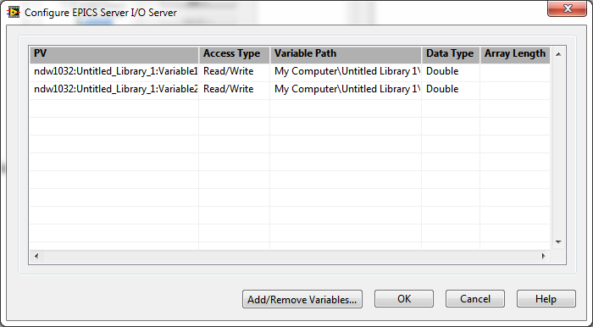
- Now access the front panel of the VI to be served via EPICS, and go through each front panel item that needs to be served, right click on it and select properties. 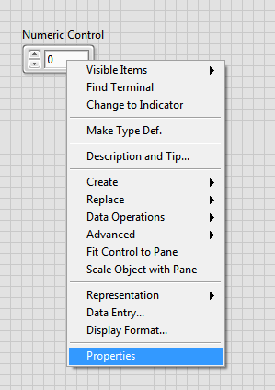
- Locate the Data Binding tab, then select Shared Variable Engine (NI-PSP) with an access type of Read/Write, browse for the appropriate Variable (not the bound EPICS one), and confirm the choices made. 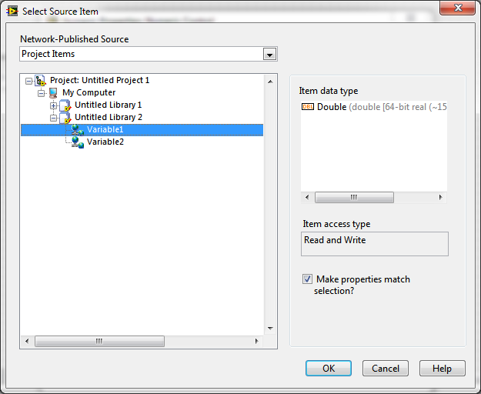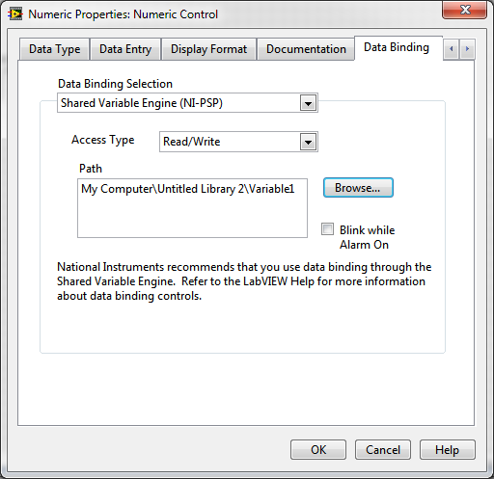
- Do this for each front panel item as appropriate.
- Go to the block diagram and add a local variable node linked to one of the EPICS bound variables (this is to ensure that the EPICS server is deployed)

At this point, running the VI should see a small dialogue pop up about the servers being deployed (shared variable and EPICS), and then everything should run linked together with the PV echoing the front panel and vice versa.

